
Cedar Grove Elementary PAC
Meeting Minutes

Meeting Information
Date: Wednesday October 3, 2019 |  | Time: 7:00 – 8:55 pm
Chair: Tracy Aiken |  | Recorder: Christine Hardt
Attendance (14)
Tracy Aiken , Chair | Eliina Friesen, Vice Chair |  | Lyle Magnus, Treasurer
Christine Hardt, Secretary | Olwen Cowan, Principal |  | Sue Girard, School Board Trustee
Tamara Hedden | Karen Graves |  | Scott Davis
Dawn Bartlett | Yoshiko Beauchesne |  | Tara Robens
Urszula Dragowska | Nick Weber
Regrets:
Housekeeping |  |  |  | Action Items
- Call to Order 7:00pm
- Introductions
- Additions to Agenda: parent education
- Minutes from last PAC meetings: Sept 9, 2019
Revisions: None
Motion to Approve: Karen Graves, Seconded by: Nick Weber
- Outstanding Action Items:
- Request for student involvement in PAC – Completed, have a plan of action (see September meeting minutes)
- Courtney to purchase Rubbermaid containers and re-organize the kitchen. – pending
- Baking supplies budget for Ms. Calvori – Completed, added item to PAC budget
- Guest Speaker: Patrick Bocking presented the SD46 2019-2023 strategic plan. It is available on the SD46 website: https://sd46.bc.ca/wp-content/uploads/SD46-Strategic-Plan-2019_digital.pdf
- Vision: We are a community engaged in lifelong learning and education excellence
- Mission: We support and inspire each student to experience joy and fulfillment in realizing their potential as a knowledgeable, confident, and contributing citizen in the global community.
- Affirmation: The Board of School District 46 affirms its commitment to Indigenous Peoples and Reconciliation by building relationships and deepening understanding of Indigenous history, worldviews, and ways of knowing.
- Values: Ethics, Inclusion, Collaboration & Equity, Innovation, Respect & Responsibility, Celebration
- Refined goals
  - Affirmation
  - Values: innovation – risk-taking
  - Student voice
  - Mental health / social and emotional skills
  - Care of our planet and its changing climate
  - Digital literacy
  - Fine arts
  - Inclusive education
- Regular Reports |  |  |  |  | Action Items
  - Chair’s Report: Tracy Aiken
- Thank you for coming, great turn out again
- Have had lots of people stepping in to help, there’s been great energy and lots going on.
- Andrea Sinclair is still scheduled to come to the coast for a parent information night
  - Treasurer’s Report: Lyle Magnus
- Bank Balance: $16,563.81
- Gaming Account Balance: 13,300.83
- Bambora is working well, they do a regular daily automated deposit, have had 81 transactions so far.
7.3 Principal’s Report: Olwen Cowan  - Have rescheduled the winter performance to Thursday Dec. 19th, matinee and evening  - Bus supervision – have been working on it for the last month. A bus supervisor is now on duty starting at 8am. This starts on Monday October 7th; we will have supervision from 8am till when the bell rings.  - Working on the 4 key words with the school community. Right now the focus is on kindness.  - Looking at the school growth plan to align it with the district’s strategic plan. Olwen will share the results at the next PAC meeting; this will be an ongoing conversation.  - Foundation skill assessments for grade 4 & 7students are starting. The data generated by the testing is useful in how well students are progressing in the foundation skills of reading, writing and numeracy. If your child has adaptations in the classroom, the same adaptations will be made for the testing. Total time to take the tests is 6-8 hours, but not all at once – they are done throughout the next month.  - The open house went really well. Had a good turnout and the staff were happy to meet the families. |  |  |  |  | Cedar Grove school growth plan to be reviewed at next meeting.
  - School Trustee Report: Sue Girard
- Not much new to report since our last meeting was just 3 weeks. The review of the strategic plan covered a lot of what is going on now.
- Attended a climate action forum to get a feel for how the community is feeling about the action plan. Sat with teachers and students and heard their thoughts. Many youth are worried about their future; a new term being used to describe this is ‘eco-anxiety’.
- Attended a meeting to discuss the playing fields on the coast. There is representation from the school board, local government, sporting clubs and community volunteers. Looking at the maintenance issues and getting input from greens-keepers.
- Sue sits on the traffic safety committee and is looking for input on what we would like to see done to improve traffic issues.
- DPAC Report: Scott Davis  - First DAC meeting this year was Sept 26th, it was well attended by all school PACs.  - Patrick and Stephanie presented the new strategic plan, similar to tonight’s presentation.  - Marilyn Baines from the Healthy Schools program reported that there is an action plan coming for Mental Health, including a program for sexual identity and orientation. Handouts were forwarded to the PAC email address and we will post on our website.  - DPAC elections are coming up at the next meeting.  - Tracy Aiken and Scott will be attending a meeting next week to kick off the family engagement speaker series. There are representatives from each school, Olwen will also be attending.  - Next meeting: 7pm Thursday October 24th @ Chatelech |  |  |  |  | Tracy to post Healthy School handouts on PAC website.
- Old Business |  |  |  |  | Action Items
8.1 Budget: Christine and Tracey reviewed the draft budget with the group. The following changes were agreed upon:  - Change CGE gear to $1500 revenue and $1000 expenses to cover PAC purchases for school sales throughout the year  - Remove the $1000 mural expense. Olwyn confirmed that the mural is finished.  - Add School Baking $250 to the expenses for Ms. Calvori’s baking program.  - Discretionary fund and gaming expense disbursements to be adjusted based on updated totals.  - It was noted that we have quite a bit of money available through the discretionary fund and the gaming account. Christine asked if we would like to consider any large purchases for the school this year; i.e. do we need laptops or iPad? Olwyn will check with the teachers. Any requests coming in throughout the year would be applied to the discretionary fund or gaming account, so we do not need to add all requests to the budget at this time.  - It was suggested that we ask the students what they would like to see the PAC spend money on for the school. Tara-will go to the classes for a brainstorm and report at next meeting  - Motion: Scott Davis motioned to accept the 2019/20 draft budget with the discussion revisions, seconded by Eliina Friesen. Motion was approved. |  |  |  |  | Tara to ask students what they would like purchased for the school.  Motion Passed: 2019-2020 PAC budget was approved
9. New Business
  - Fall Calendar: A copy of the draft school calendar was distributed and Tracy reviewed it up to December. Parents were asked to review the rest of the year and email the PAC if we have any changes or suggestions.

9.2 Beer & Burger Night: Tickets are now for sale for the Cedar Grove beer and burger night, October 24th at the 101 Brewhouse. Please mention it to your friends!
9.3 Teacher Wish List Approvals:  - Tracy reviewed the teacher wish lists requests that have been submitted to date (see attachment). All of the requests fit within the wish list budget and there is still room for additional requests.  - It was noted that not all teachers submitted requests, and that this is a regular occurrence. Requests will sometimes come later in the year.  - Motion: Nick Weber motioned to accept all the teacher wish list requests received to date, seconded by Scott Davis. Motion was approved. |  |  |  |  | Motion Passed: Teacher wish lists requests received up to October 3rd were approved.
9.4 Additional Agenda Item:  - Parent Education: It was noted that the students are getting a lot of education around indigenous cultures. Can we provide a parent education night? Olwyn noted that Gus Guszek teaches the program, we could bring him in for a parent night. It was noted that it could be marked at ‘things you wish you learnt’. |  |  |  |  | Olwyn to ask Gus Guszek if he is interested in providing a parent education session.
9.5 Spending Decisions: There were no requests for spending decisions at this meeting, other than the teacher wish lists approved in item 9.3.
Meeting Adjourned at: 9:10pm |  | Next Meeting: November 6, 2019 at 7pm

Attachments:
- 2019/2020 PAC Budget – Final version including this meeting’s updates
- Draft 2019-2020 Cedar Grove PAC Calendar
- Teacher Wish List Requests

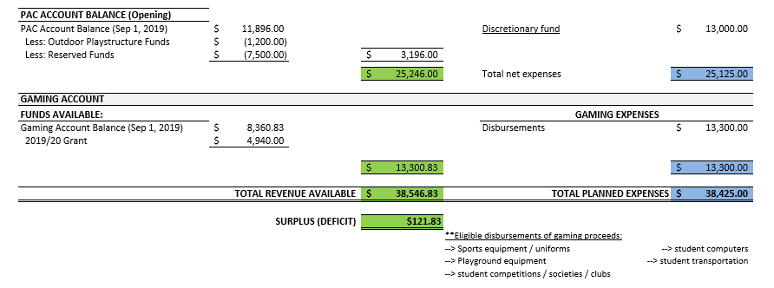
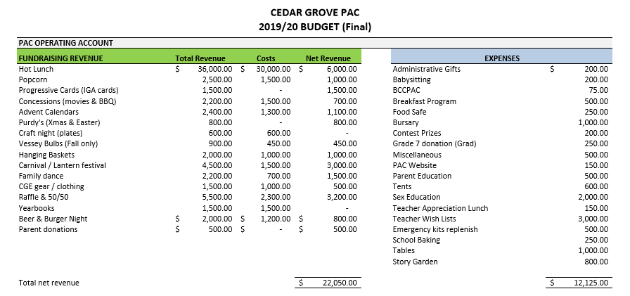
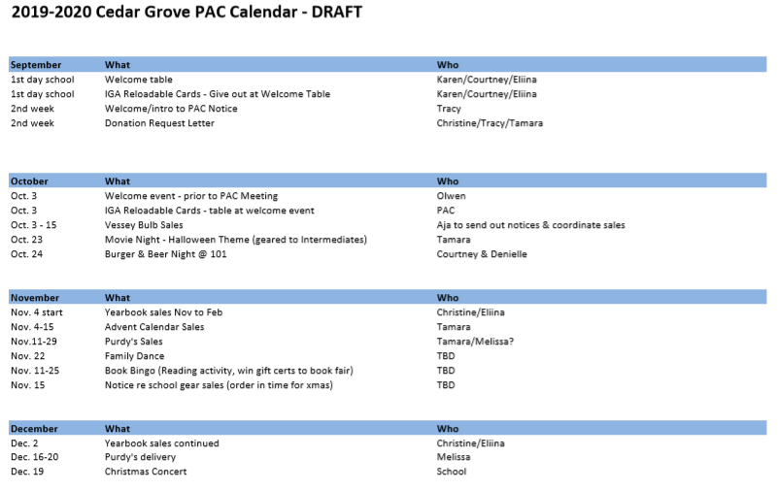
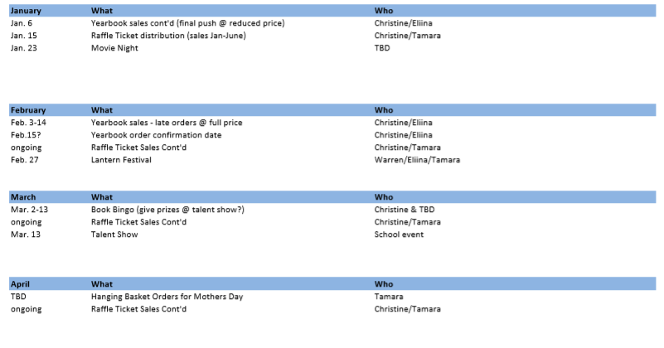
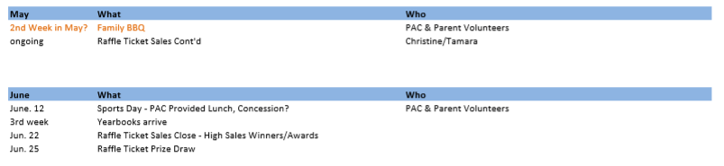

2019/2020 Teacher Wish List Requests
October 3, 2019

Division Number | Grade | Teacher | Item | Cost
1 | 6/7 | Jen MacInnes | Art Drying Rack | $ 298
2 | 6/7 | Peter Metcalfe
3 | 5/6 | Gordon Tultz | X-acto knives | $ 144
4 | 4/5 | Sylvia Calvori | Muffin Tins & Button Maker | $ 105
5 | 4 | Signy Bjarnason | Owl Rehab Visit | $ 350
6 | 3 | Michele Curry | ECR4kids | $ 103
7 | 2/3 | Meghan Hewitt | Marble works, magnetic tiles | $ 160
8 | 2 | Robyn Valenta | Math Website | $ 200
9 | 1 | Robert Emmerson
10 | K/1 | Karen Van Bemmel | Chicken eggs in an incubator | $ 250
11 | K | Lorraine Radford
 | Library | Jackie Reid | Breakout EDU Kit | $ 469
 | Resource Room | Vogel/Prince | Cabinet with shelves | $ 500
 |  |  | Total Cost | $ 2,580

